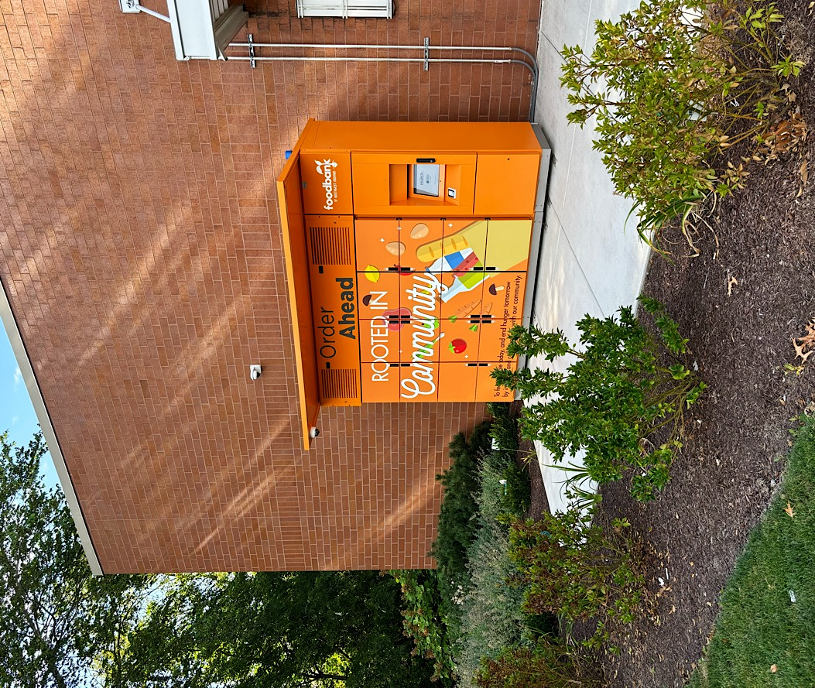

SMART FOOD LOCKER ACCESS PROGRAM
Grant Proposal
Submitted to: [Funder Name]
Funding Program: [Grant Program Title or Reference Number]
Submission Date: [Month, Year]

[Your Logo]

[Organization Name]
[Street Address]
[City, State, ZIP]
[Website URL]
[Charitable Registration # or EIN]
Contact Person:
[Full Name, Title]
[Email Address]
[Phone Number]
(Add partner details below if this is a joint application)
In Partnership With:
[Partner Food Bank Name]
[Partner Contact Name & Title]
[Partner Address / Website]

Instructions for using this template
⚠️ DELETE THIS PAGE BEFORE SUBMITTING YOUR PROPOSAL
(This section is intended only to guide you in completing the template.)

About This Template
This grant proposal template was developed to help community organizations, food banks, and partner agencies effectively communicate their goals, impact, and innovation when applying for charitable food-access funding.
It draws on insights and best practices from charitable partners, including organizations that have successfully implemented smart food locker programs and other technology-enabled access initiatives.
The structure follows widely accepted standards for philanthropic and government grant proposals, with clearly defined sections such as Executive Summary, Problem Statement / Needs Assessment, Project Description/Solution, Goals & Objectives, Methodology, Budget, Sustainability, and Attachments.

How to Use It
- Look for [bracketed fields] throughout the document. These indicate where you should insert your own organization’s information, data, or region-specific context.
Example: Replace [your state or county] with the name of your service area.
- Tailor the content to reflect your organization’s mission, tone, and program design. The sample language provides a strong foundation but should be adapted to your voice and evidence base.
- Incorporate local data and credible sources such as:
  - Feeding America’s “Map the Meal Gap” for county-level food insecurity rates
  - U.S. Department of Agriculture (USDA) and U.S. Census Bureau data
  - MIT Living Wage Calculator for cost-of-living context
  - State or regional health department reports
- Leverage AI tools such as ChatGPT to help refine sections, summarize data, or adjust tone for specific funders — but always review and verify all factual information before submission.
- Use your brand voice and design — add your logo, color palette, and consistent formatting across pages. Funders appreciate clear, professional presentation, but authenticity and clarity matter most.

Tips for Effective Customization
- Be specific and local. Use your community data, quotes, and stories wherever possible.
- Be consistent. Align language, goals, and budget figures across all sections.
- Be transparent. If your program is new or evolving, emphasize partnerships, pilot success, and scalability rather than overstating outcomes.
- Show impact. Include measurable objectives and, where possible, qualitative feedback (participant quotes, testimonials, or case examples).
- Edit for readability. Funders value concise, well-organized proposals that clearly connect need → solution → outcomes.

Disclaimer
This template is provided as a guidance and reference tool.
It does not constitute legal, financial, or professional grant writing advice. Users are responsible for ensuring that all information entered is accurate, appropriate for the intended funder, and aligned with their organization’s mission and policies.
While the examples, citations, and references reflect proven practices from charitable food-access programs, every proposal should be customized to your organization’s circumstances, regional context, and funding opportunity requirements.
You are encouraged to adapt, modify, and expand this template to fit your needs — it is designed to be a flexible foundation, not a final draft.

⚠️ Reminder: This page is for internal use only. Please delete this entire section before submitting your completed proposal.

Executive Summary
This proposal seeks [amount] in funding to [establish or expand] a Smart Food Locker Access Program—a secure, contactless, and climate-controlled system for distributing nutritious food to individuals and families facing food insecurity.
The goal of this project is to expand equitable food access through a flexible, technology-enabled distribution network that complements traditional pantry operations and better serves working families, seniors, and individuals facing mobility or transportation challenges.
The proposed food locker program enhances overall system efficiency and community reach by optimizing volunteer capacity and staff time, reducing operational pressure on in-person distributions, and extending access to residents in [remote / underserved / high-demand] areas through strategically placed [locker hubs / satellite pickup points]. Each locker site—whether installed [outside an existing food bank / at a partner agency / in a public access location such as a library, school, or municipal site]—acts as an extension of the food distribution network. These units provide safe, temperature-controlled pickup options around the clock, allowing families to collect food parcels privately and conveniently, at times that fit their schedules.
This model supports both dignity and efficiency. It empowers recipients with genuine choice and privacy, strengthens the resilience of food bank operations, and equips [Organization] with practical, data-informed ways to reach those they have historically struggled to serve—transforming food assistance from a limited-time service into a 24/7 community resource.

Introduction
[Organization Name] is a registered [nonprofit / charity] dedicated to ending hunger and improving equitable access to nutritious food. Founded in [year], our mission is to provide creative, community-driven solutions that meet people where they are.
We have distributed [X] meals annually through a network of [number] partner sites. Building on this experience, we are now integrating technology-enabled food distribution to improve accessibility and reduce stigma. Our management team includes leaders in logistics, food security, and digital innovation, supported by [number] volunteers and key partners such as [partners].

Problem Statement / Needs Assessment
Food insecurity continues to affect a significant portion of [your state and/or county]. With rising living costs, many working households earn too much to qualify for traditional assistance yet too little to meet the cost of living. The result is a growing population of under-served, employed individuals struggling to afford nutritious food.
According to Hunger Free America, “nearly 10 percent of employed U.S. adults (14.3 million workers) lived in food insecure households.
[Use this paragraph to highlight county- or city-specific data that contextualizes the problem. Good sources include:
- State Department of Health or Agriculture annual hunger or nutrition reports.
- Feeding America’s “Map the Meal Gap” (provides county-level food insecurity rates).
- U.S. Census Bureau’s American Community Survey (ACS) for poverty, median income, and housing cost data.
- Local Living Wage Calculator (MIT) to show the gap between income and cost of living.
Example format:
In [State/County], an estimated XX% of households—or roughly X in X residents—experience food insecurity (Feeding America, 2023). The median household income is $XX,XXX, while the living wage for a family of four is $XX,XXX (MIT Living Wage Calculator, 2024). Nearly X% of renters in the county spend more than 30% of their income on housing costs, leaving limited resources for food and other essentials (U.S. Census Bureau, 2023). Local food banks report a X% increase in service requests over the past year, particularly from working families and seniors on fixed incomes.
“Food insecurity has serious impacts on well-being, contributing to poor school attendance, lower workplace productivity, and negative health outcomes,” notes the California Association of Food Banks (2022).]
Food lockers provide an innovative response—offering discreet, anytime access that reduces missed opportunities for assistance.

Solution / Project Description
The proposed solution is the Smart Food Locker Access Program—a flexible, technology-enabled model that extends the reach of traditional food pantries. Smart lockers allow individuals and families to collect food privately, safely, and at any time that fits their schedule. Each unit is climate-controlled to preserve food quality and can be installed [outside an existing food bank / at a partner site / within a community hub]. By integrating these lockers into the existing distribution network, our [Organization] can transform limited-hour operations into a 24/7 community resource.
Implementation will occur in partnership with [partner organizations / municipalities / local agencies] to ensure equitable access and local alignment. Each installation site will be selected based on community need, accessibility, and proximity to existing pantry operations. Data from [Feeding America / local food bank usage reports / community health assessments] will inform site selection, helping identify neighborhoods with high unmet demand. The lockers will be managed through a secure, cloud-based software platform that allows administrators to monitor temperature, track distribution, coordinate restocking, and collect anonymized data for reporting and continuous improvement.
This program leverages technology to advance equity, dignity, and inclusion in food access. By removing barriers such as fixed operating hours, transportation challenges, and social stigma, the model ensures that families balancing work, childcare, or mobility limitations can still access nutritious food. The privacy and flexibility of smart lockers empower recipients to collect food at times that work for them, while also enabling food banks to reach households they have historically struggled to serve.
Together, these features position the Smart Food Locker Access Program as both an operational innovation and a social one—combining technology, empathy, and data-driven insight to build a more inclusive and resilient food assistance system.

Program Flexibility and Operating Models
Recognizing that no two food programs operate in exactly the same way, the Smart Food Locker system will be configured to match the unique needs of each participating site. The technology supports multiple service modes that allow us to choose the most effective approach for each location and client group.
For example, some sites may use a scheduled pickup model, where clients reserve food parcels in advance—ideal for choice-based or pre-packed boxes. Others may adopt a request-based system, allowing clients to submit food preferences online or through a mobile form before pickup. In areas where immediate assistance is critical, lockers can operate in an on-demand mode, stocked with ready-to-collect parcels for emergency or after-hours access.
This flexibility ensures that each food program—whether urban or rural, large or small—can tailor the system to fit its community, staffing, and volunteer resources. The system functions seamlessly with existing pantry management workflows and can operate as a standalone solution or integrate with other platforms through simple digital connections.
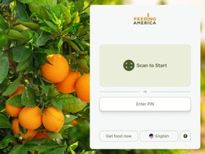 | 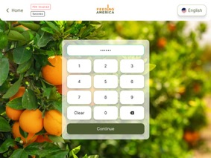
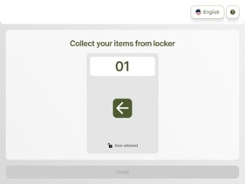 | 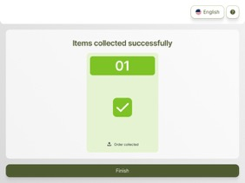

Goals and Objectives
Goal: To expand equitable access to nutritious food through innovative, technology-enabled distribution.
Objectives:
1. Install [number] smart food locker units across [region] by [date].
2. Serve [X] households monthly, providing [Y] food parcels.
3. Reduce missed pickups and stigma through 24/7 flexible access.
4. Collect and analyze usage data to optimize outreach and inform expansion.

Methodology and Timeline
Activity | Timeline | Responsible Party | Expected Deliverable / Milestone
Secure funding commitments and confirm project partners | Month 1 | Project Lead / Grants Manager | Signed MOUs, finalized project budget
Site selection, permitting, and stakeholder engagement | Month 2 | Operations Manager | Approved installation sites
Locker procurement, customization, and shipping | Month 3–8 | Vendor / Logistics Team | Delivery of locker units to site
Software setup and integration with Food Bank database | Month 5-8 | Technical Integration Team | Live cloud dashboard and user management system
Food sourcing agreements and workflow planning | Month 3–5 | Program Coordinator | Signed food supply and volunteer agreements
Install lockers and perform operational testing | Month 8 | Installation Partner / Site Lead | Lockers installed and commissioned
Launch pilot operations and distribute access codes | Month 9 | Distribution Team | Pilot launch event, first 100 users onboarded
Collect user feedback and program data | Month 9–15 | Monitoring & Evaluation Lead | Monthly progress reports
Analyze data and develop scalability report | Month 15 | Project Manager | Evaluation report and recommendations for expansion

Budget and Funding Request

Expense Category | Amount (USD) | Description / Justification
Food Locker Hardware | $XX,XXX | Procurement, shipping, and installation of climate-controlled lockers (ambient/chilled/frozen)
Software & IT Integration | $X,XXX | Smart locker management system, reporting dashboard, and technical support
Food Sourcing & Logistics | $X,XXX | Transportation, cold-chain supplies, packaging materials, and food handling equipment
Staffing & Volunteer Coordination | $X,XXX | Program coordinator, part-time staff, volunteer training, and scheduling
Site Preparation & Permitting | $X,XXX | Site electrical setup, signage, and local permitting fees
Monitoring & Evaluation | $X,XXX | Data collection, participant surveys, and outcome reporting
Community Outreach & Awareness | $X,XXX | Local marketing, community events, and partner engagement
Contingency (5%) | $X,XXX | Buffer for unforeseen costs or inflation adjustments
Total Funding Requested | $XX,XXX

Project Outcomes
Outcome 1: Increased access for low-income individuals unable to attend regular food distributions.
Outcome 2: Reduced household expenses and stress through flexible, private pickup options.
Outcome 3: Pilot data, best practices, and community feedback to guide future expansion.
Here are some authentic voices from other food banks who have participated in similar smart food locker programs. Their feedback highlights how this model enhances accessibility, dignity, and peace of mind for individuals and families who face barriers to traditional food assistance.
“Thank you for this opportunity as I have a hard time getting around the time frame of other pantries.
“Thank you for what you’re doing for the community… we really appreciate it.”

Neighbors have shared how much the flexibility of lockers matters — especially those living with disabilities or transportation challenges:
“My disability prevents me from waiting in line. These lockers are a blessing.”

Others express deep gratitude for stability during hard times:
“Thank you!!! You are helping to keep our family fed during a really tough time.”
“I appreciate this. I just lost my job.”

Sustainability Plan
The Food Locker Access Program is designed for long-term viability through partnerships, operational efficiency, and scalable infrastructure.
- Partnerships: Collaboration with local food banks, municipalities, and retail donors.
- Community Ownership: Local organizations manage maintenance and client engagement.
- Cost Efficiency: Low operating costs compared to traditional pantry models.
- Data-Driven Funding: Use performance data to demonstrate impact and secure ongoing support.

Attachments accompanying this proposal
This section may include supporting materials such as:
- Case studies of existing locker deployments.
- Technical specifications and maintenance plans.
- Letters of support from community partners.
- Photos, site maps, or media coverage.
- Financial statements an registration documents.

